# Assignment **1** Of

**Network & Distributed System Lab (CS2051)**

**Masters of Technology in Computer Science And Engineering**

**submitted to**

**Dr Suvrojit Das Associate Professor Dept. of CSE**



**National Institute of Technology, Durgapur**

submitted by Arghya Bandyopadhyay RollNo. 20CS4103

29 June 2021

# Objective: Write a TCP Chat Server-Client Program using Sockets

# **Solution:**

//This is the Server side implementation of TCP Chat

#include<string.h>

#include<sys/socket.h>

#include<netinet/in.h>

#include<unistd.h>

#include<stdio.h>

#include <stdbool.h>

int TCP_ChatServer(int client_desc)

{

const int BUFFER_SIZE = 4096;

char msg[BUFFER_SIZE];

int msg_len = 0;

while((msg_len = read(client_desc, msg, BUFFER_SIZE)) != 0)

{

printf("%s %d %s","[User",client_desc,"] Msg Received :");

fflush(stdout);

write(fileno(stdout), msg, msg_len);

if(msg[0] == 'b' && msg[1] == 'y' && msg[2] == 'e')

return 0;

printf("%s %d %s","[User",client_desc,"] Enter Response :");

fflush(stdout);

msg_len = read(fileno(stdin), msg, BUFFER_SIZE);

write(client_desc, msg, msg_len);

if(msg[0] == 'b' && msg[1] == 'y' && msg[2] == 'e')

return 0;

}

return 0;

}

int main()

{

//Create Socket

int server_desc = socket(AF_INET,SOCK_STREAM,0);

//Create and Fill Address Structure for this Server

struct sockaddr_in server_addr;

server_addr.sin_family = AF_INET; //Address Family (AF_INET, AF_INET6, AF_LOCAL, ...)

server_addr.sin_addr.s_addr = INADDR_ANY; //Internet Address (INADDR_ANY-> Accept connection at any IP Address)

server_addr.sin_port = htons(9000);//Port Number (htons -> h.HOST t.TO n.NETWORK s.SHORT , Ensures proper byte ordering)

//Bind Socket Descriptor and Address Structure together

int result = bind(server_desc, (struct sockaddr*) &server_addr, sizeof(server_addr));

//Start Listioning (Tell kernel to accept connections directed towards this socket) (Puts socket into passive mode)

listen(server_desc,4);

//Server Loop

bool RunServer = true;

while(RunServer)

{

//Accept a Connection (Puts process in sleep mode if Connection Queue is Empty)

int client_desc;

client_desc = accept(server_desc,NULL,NULL); //Listening Socket

//Create Child Process to handle connection

int pid = fork();

if(pid > 0) //Parent Process

{

//Close Client Socket

close(client_desc);

continue;

}

else

if(pid == 0) //Child Process

{

//Close Listening Socket

close(server_desc);

TCP_ChatServer(client_desc);

//Close Connection

close(client_desc);

break; //Work Done! Exit Child Process.

}

else

{

printf("%s ","fork() Error!!!");

break;

}

}

return 0;

}

//This is the client side implementation of TCP Chat

#include<arpa/inet.h>

#include<sys/socket.h>

#include<sys/wait.h>

#include<netinet/in.h>

#include <stdbool.h>

#include<string.h>

#include<time.h>

#include<stdio.h>

#include<unistd.h>

#include<stdlib.h>

#include<string.h>

#include<signal.h>

#include<errno.h>

int TCP_ChatClient(int server_desc)

{

const int BUFFER_SIZE = 4096;

char msg[BUFFER_SIZE];

int len = 0;

while(true)

{

printf("%s ","Input:"); fflush(stdout);

len = read(fileno(stdin), msg, BUFFER_SIZE);

if(len == 0) //EOF

return 0;

len = write(server_desc, msg, len);

if(msg[0] == 'b' && msg[1] == 'y' && msg[2] == 'e')

return 0;

len = read(server_desc, msg, BUFFER_SIZE);

printf("%s ","Response from server :"); fflush(stdout);

len = write(fileno(stdout), msg, len);

if(msg[0] == 'b' && msg[1] == 'y' && msg[2] == 'e')

return 0;

}

return 0;

}

int main()

{

int sock = socket(AF_INET, SOCK_STREAM, 0);

struct sockaddr_in server_addr;

server_addr.sin_family = AF_INET;

server_addr.sin_addr.s_addr = inet_addr("127.0.0.1");

server_addr.sin_port = htons(9000);

int result = connect(sock, (struct sockaddr*)&server_addr, sizeof(server_addr));

TCP_ChatClient(sock);

close(sock);

return 0;

}

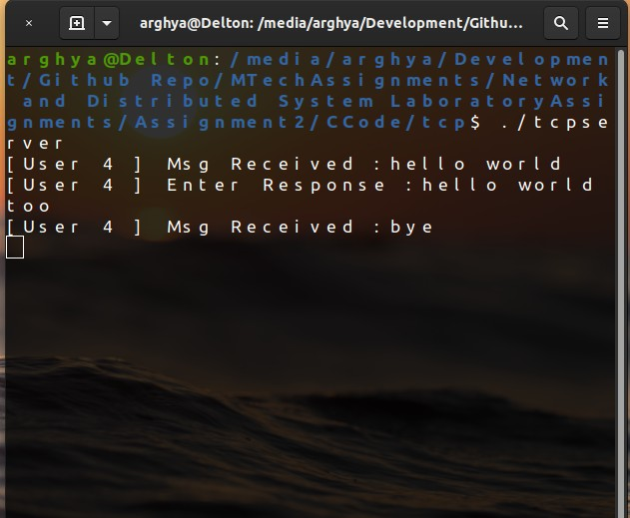 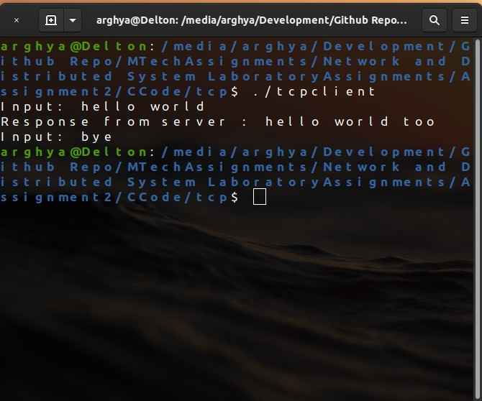

(a) TCPServer (b) TCPClient

## Figure 1: Output:TCP